A GRAFF
2231290
IT5503 Programming
Assignment 2
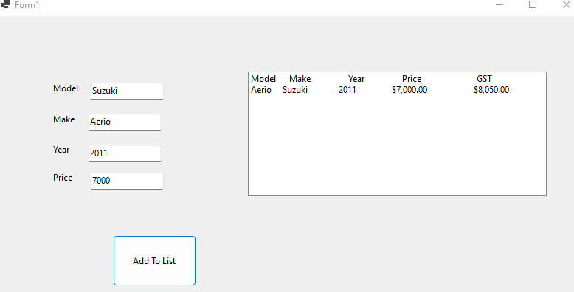
Phase 1: Basic input and Output OOP
- Correct form result

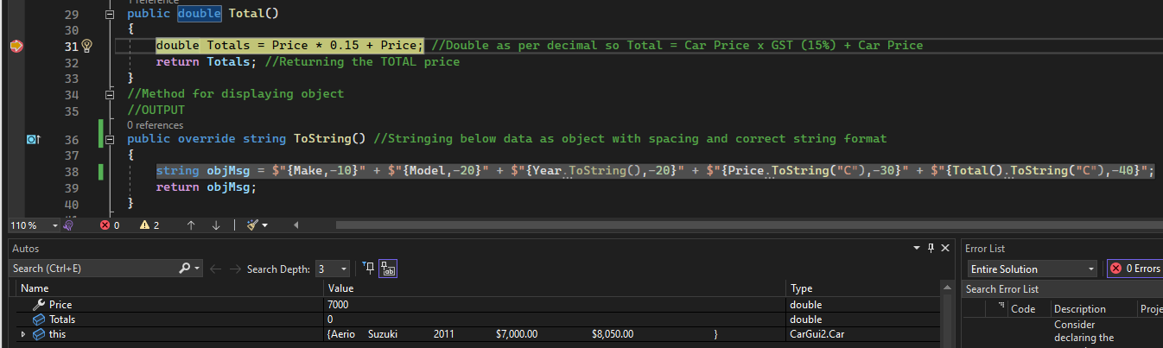
- Correct code debugging (commands and variables)

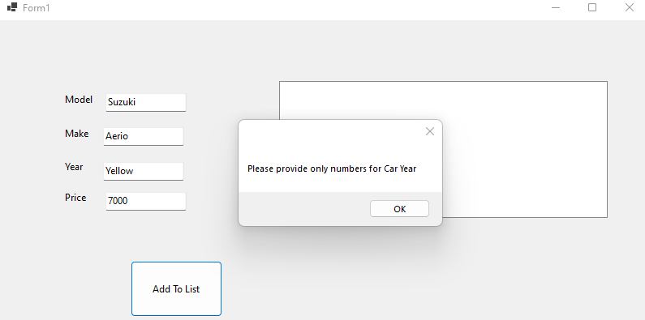
- Incorrect form result

- Incorrect code debugging (commands and variables)
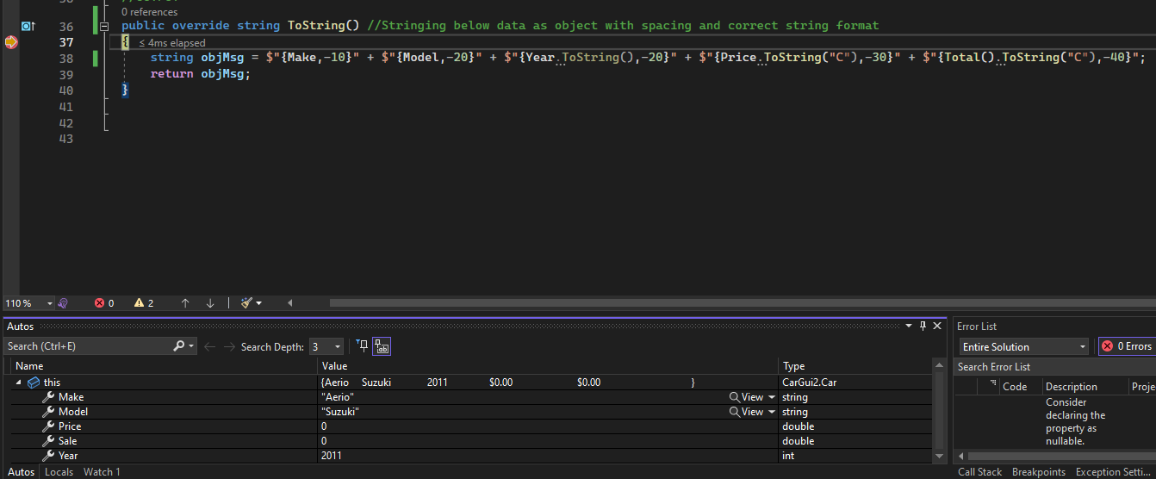

Phase 2: Basic Data Process
Design Documentation
Flow Charts
- Calculate and display average car sale price including GST
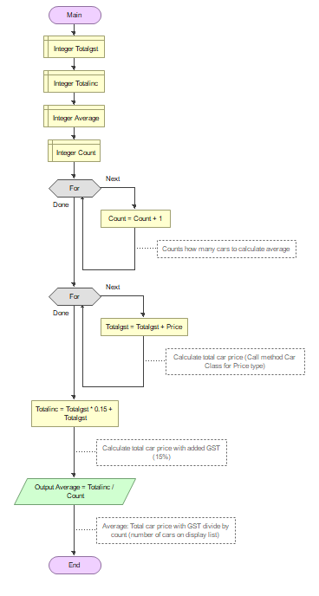

- Calculate and display the total car sale price excluding GST
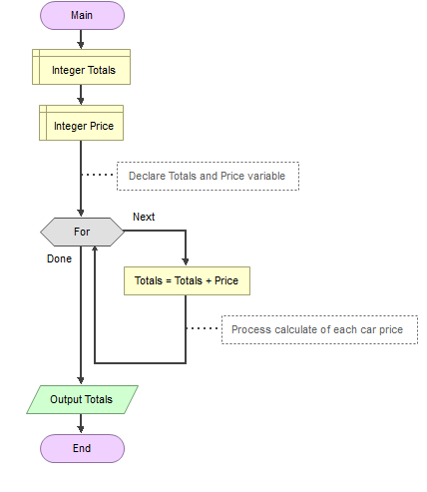

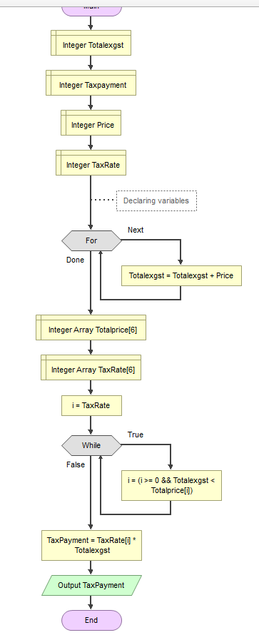

3/4. Write a taxRATE_searching method. Tax table to be implemented in two arrays. Program to calculate tax payment

Print screen testing
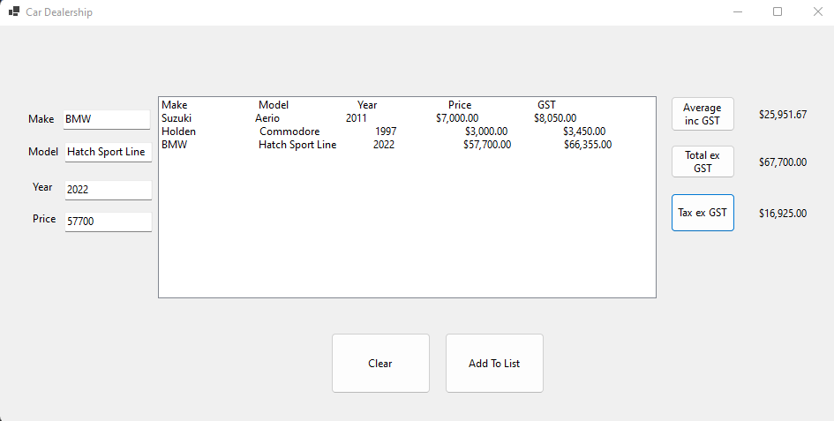

We can see: Total average including GST is correct: (8050+3450+66355/3) = 25951.67
Total price excluding GST is correct: (7000+3000+57700) = 67700
Total tax excluding GST is correct: Total excluding GST: 67700 x (Tax rate 25%) = 16925

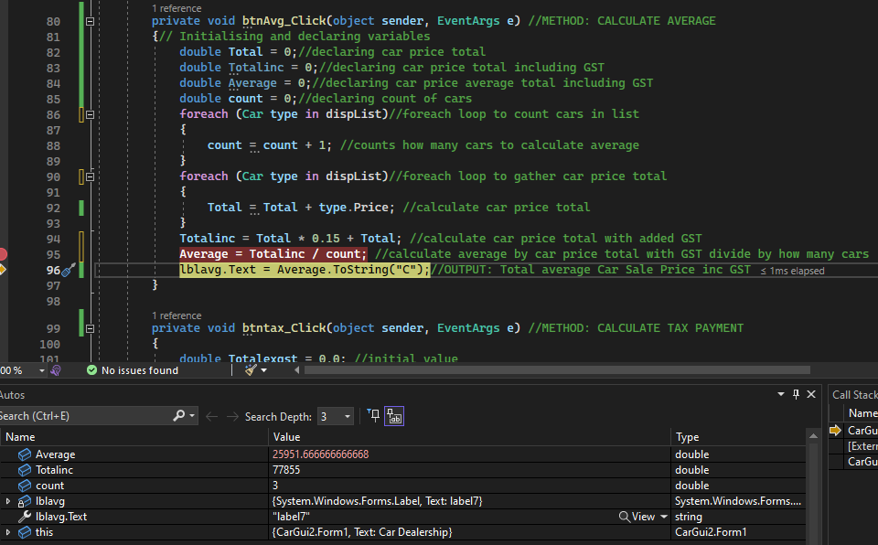

Above debugging: We can see the form, commands and variable to calculate the total average car price including GST.
We declare and initialise variables, method to count, method to calculate total car price, method to calculate total car price including GST, method to calculate total average car sale price with GST. As per formula; Average = Totalinc (Total inc GST) 77855 / count (Count of cars) 3
Total price excluding GST |  | Tax Rate
From | To
0 | $19,999 | 0%
$20,000 | $34,999 | 17%
$35,000 | $44,999 | 19%
$45,000 | $59,999 | 21%
$60,000 | $79,999 | 25%
$80,000 | More | 30%
We will test all 6 different tax rate data ranges
1. Tax Rate at 0%
As per Total ex GST amount below: $10,000.00
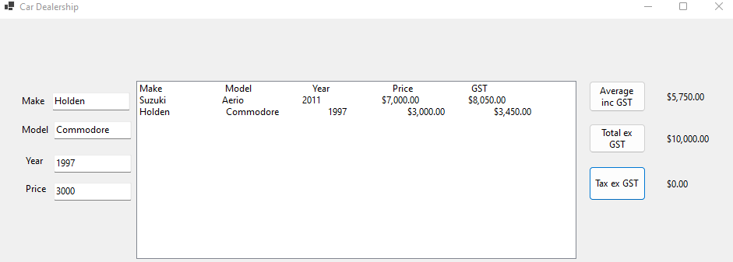
According to tax rate table: $0.00 tax to be paid

Below debugging shows us the value of [i] which is the tax rate = 0 gathered from the TaxRate arrays of different tax rate amounts. While loop measures total price ex gst against the Totalprice and TaxRate in the arrays
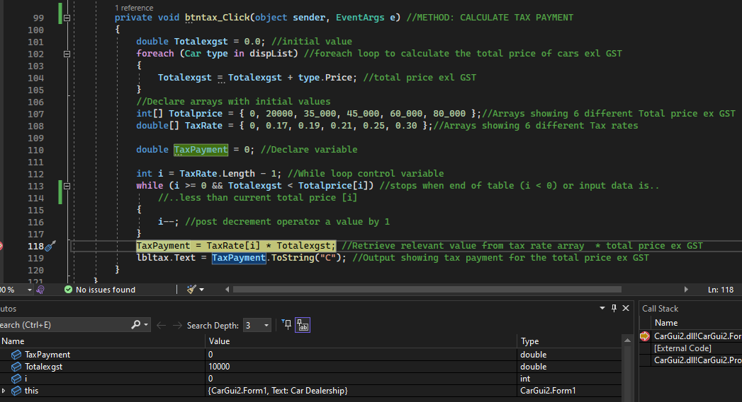

We proceed testing with other Tax Rates at 17%, 19%, 21%, 25% and 30%
2. Tax Rate at 17% for $23,000 (as per table) $23000 x 0.17: $3910 as displayed
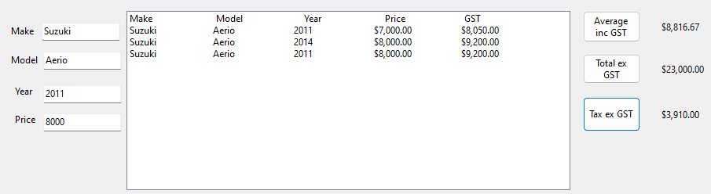

Below debugging shows the value of [i] = 1 which is the tax rate (0.17) the 1 as per positioning in the TaxRate arrays (as counts from 0)
//Declare arrays with initial values
int[] Totalprice = { 0, 20000, 35_000, 45_000, 60_000, 80_000 };//Arrays showing 6 different Total price ex GST
double[] TaxRate = { 0, 0.17, 0.19, 0.21, 0.25, 0.30 };
//Arrays showing 6 different Tax rates
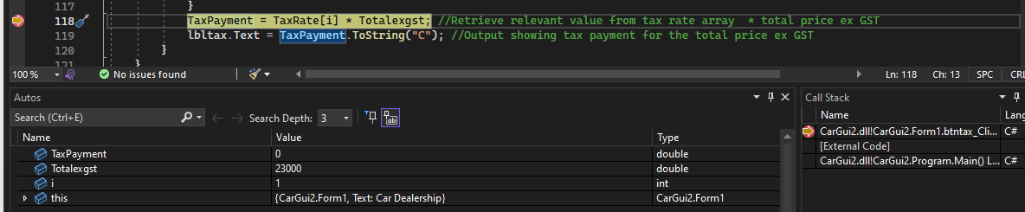

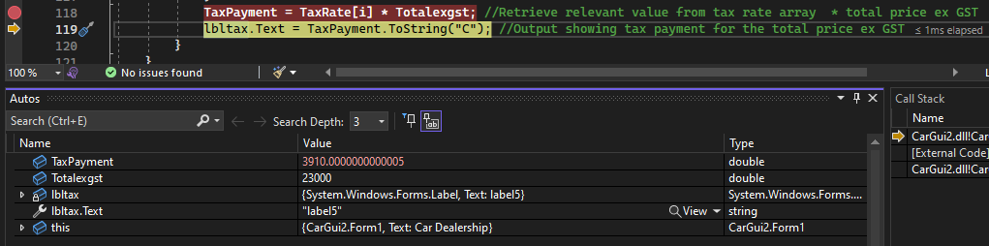
Output

3. Tax Rate at 19% for $35,000 (as per table) $35000 x 0.19: $6650 as displayed
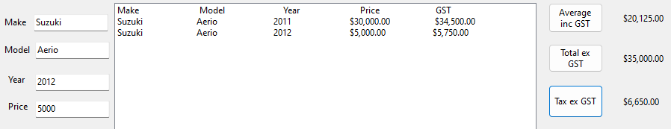

Below debugging shows [i] = 2 which is tax rate (0.19) as per positioning on TaxRate arrays (as counts from 0)
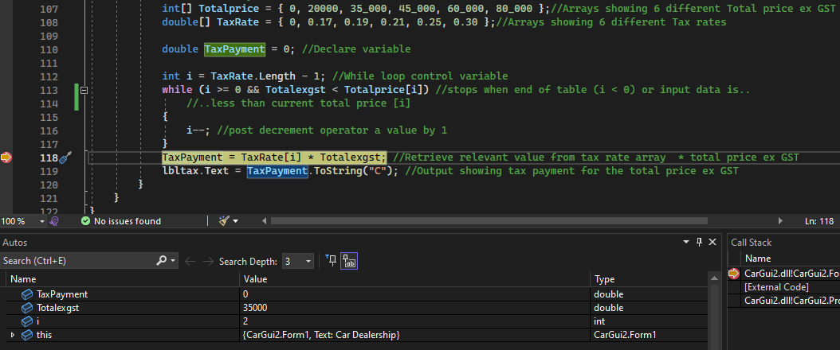

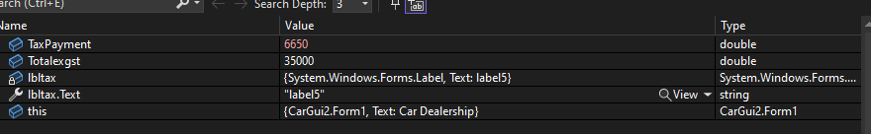
Output

4. Tax Rate at 21% for $47,000 (as per table) $47000 x 0.21: $9870 as displayed
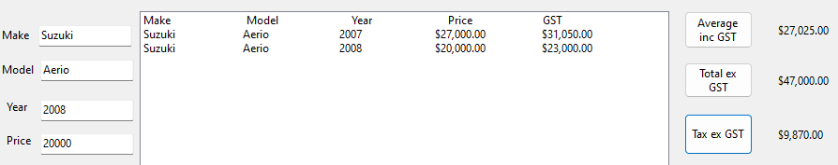
Below debugging shows [i] = 3 which is tax rate (0.21) as per positioning on TaxRate arrays (as counts from 0)
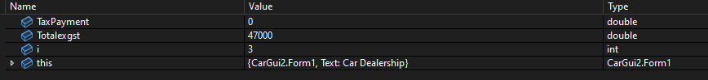
Output
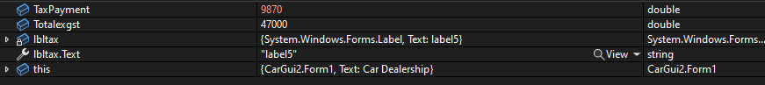
5. Tax Rate at 25% for $63,000 (as per table) $63000 x 0.25: $15750 as displayed
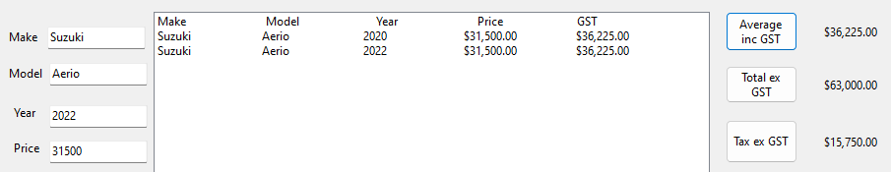

Below debugging shows [i] = 4 which is tax rate (0.25) as per positioning on TaxRate arrays (as counts from 0)
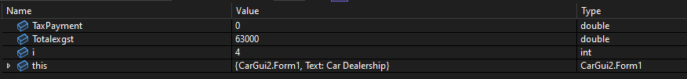
Output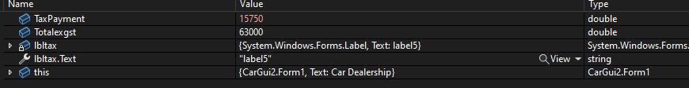
6. Tax Rate at 30% for $242,564 (as per table) $242564 x 0.30: $72769.20 as displayed
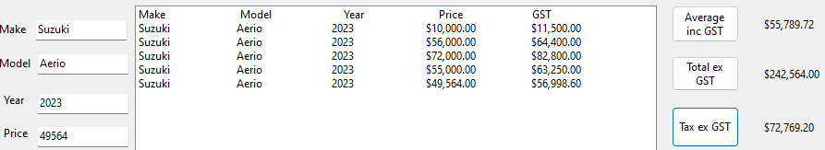
Below debugging shows [i] = 5 which is tax rate (0.30) as per positioning on TaxRate arrays (as counts from 0)
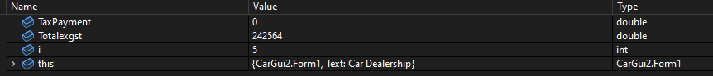
Output
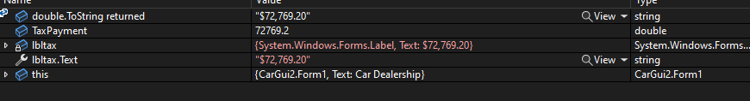

Phase 3: Basic File Management
Below we can see the saved data on the disk drive
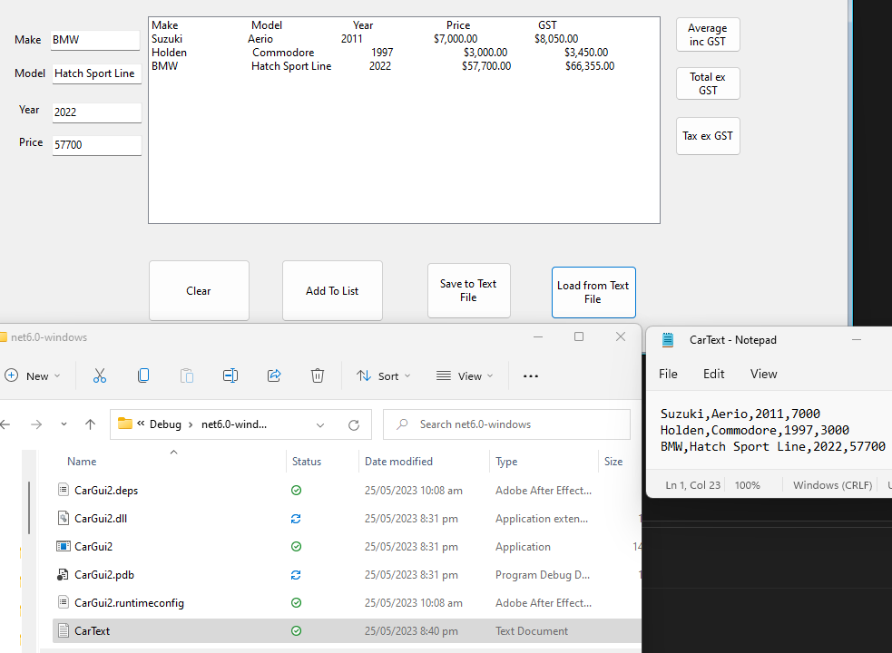
This is by right clicking mouse button on project file, select open containing folder, while in file explorer click bin>>debug>>net6.0 and select CarText(.txt) to see the saved data

We can see savedSuccess returns a “true” value when saving text to file button click, therefore MessageBox.Show(“Data successfully being saved”);
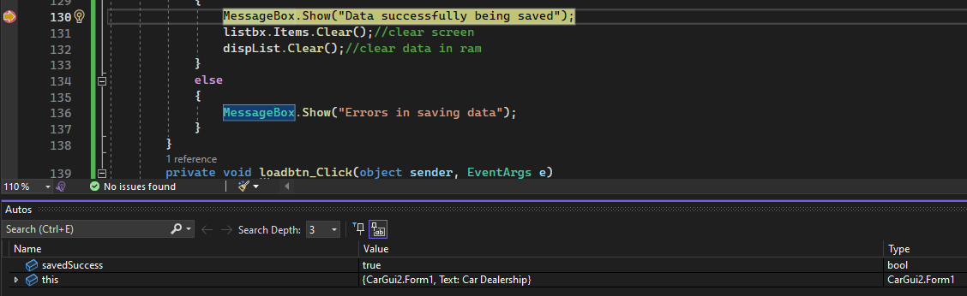

Below is the debugging behind the loading button – we can see the stored values (11 counts = 11 car types in carList)
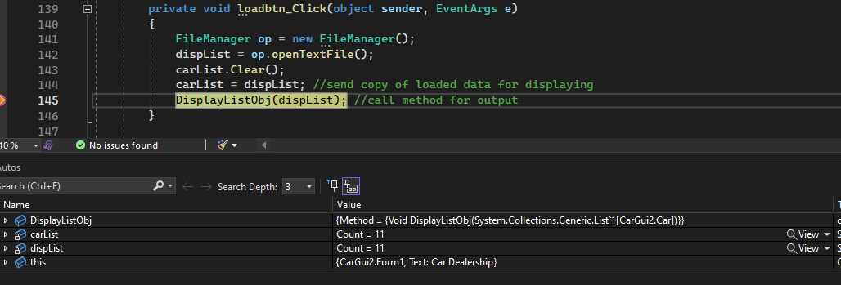
carList arrays of vehicle saved details
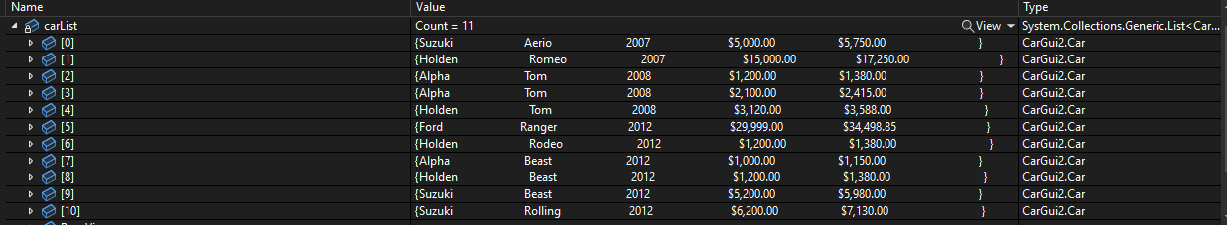
FileManager Class loading data from text file

Phase 4: Basic Search in the Objects
Method1. searchbyCarMake()
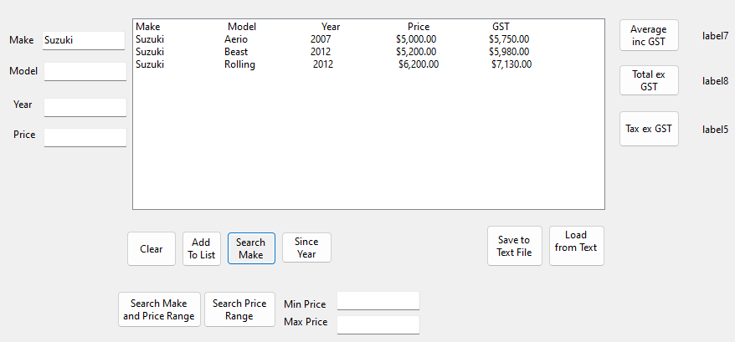
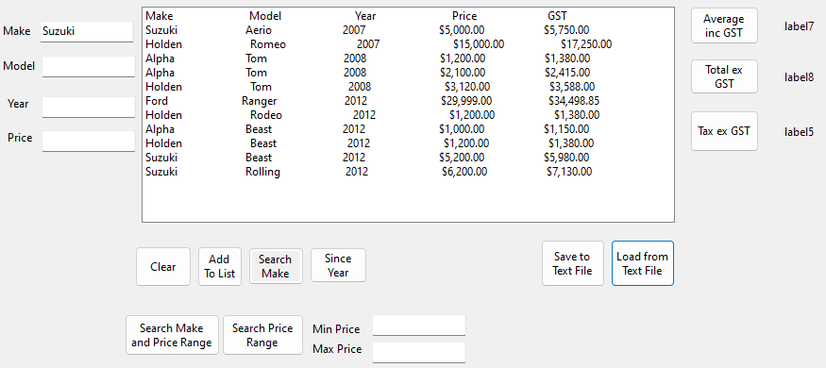
Searching for Suzuki Make only, we can see second image shows filters for Suzuki only

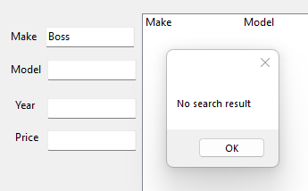
Debugging below confirms second image count of 3 Suzuki Make & “No search result” message when “Boss” make is not found
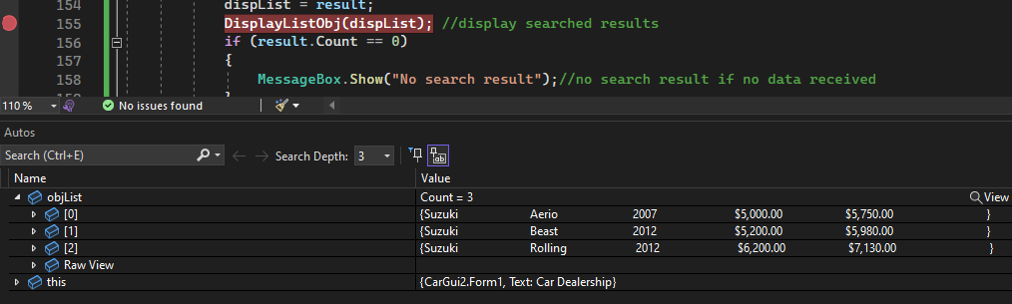

Method2. searchforCarsSinceTheYear()
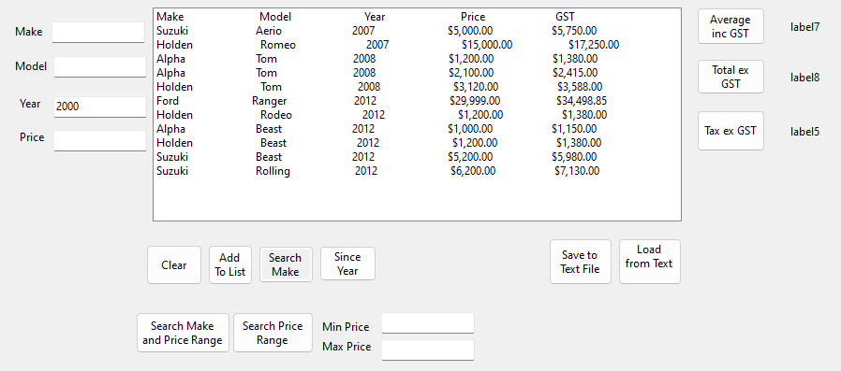
Searching for Cars from 2010 only, we can see second image filters Car Year from 2010
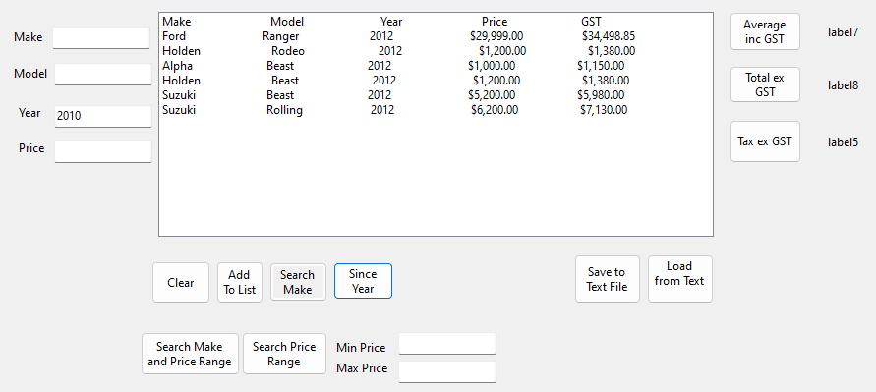

Debugging below confirms second image count of 6 cars from year 2010 & No search result pops up if no data received
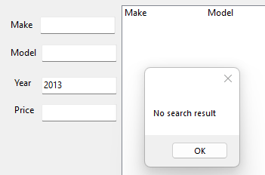
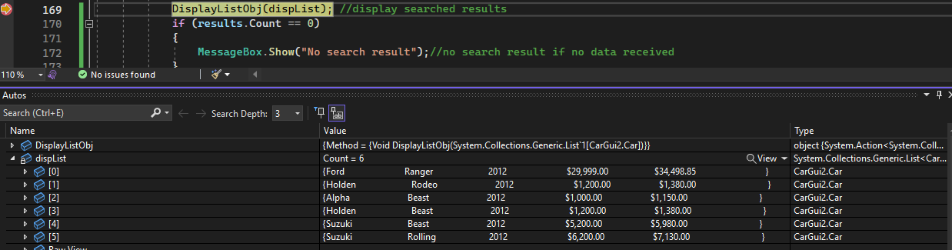

Method3. searchforCarsWithinthePriceRange()
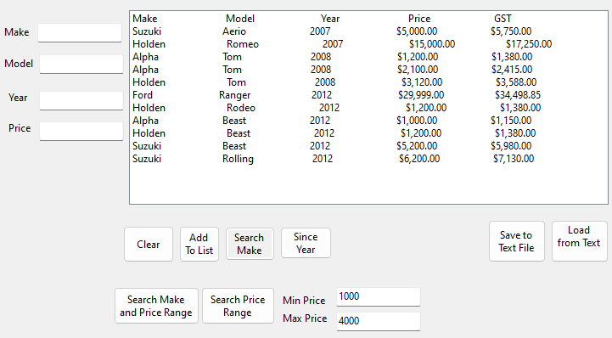
Searching for Cars from $1000-$4000 price range, we can see the second image filters 6 cars within the price $1,000 - $4,000 range only
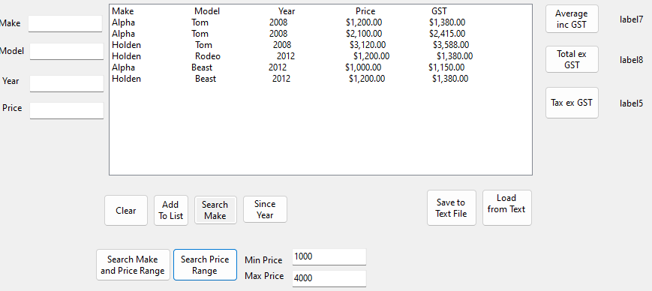

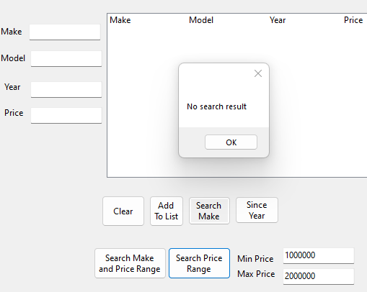
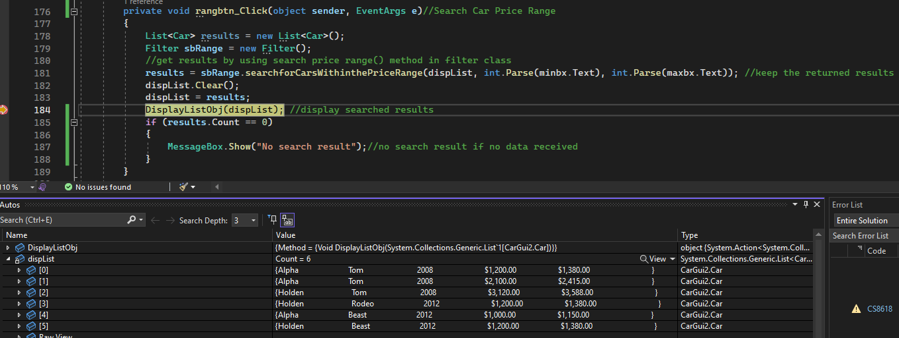
Debugging below confirms second image count of 6 cars from year 2010 & “No search result” pops up if no data received

Method4. SearchbyCarMakeandPriceRange()
Searching for “Alpha” Car make and price range of “$1000-$2000”, we can see the second image filters both the make and price accordingly
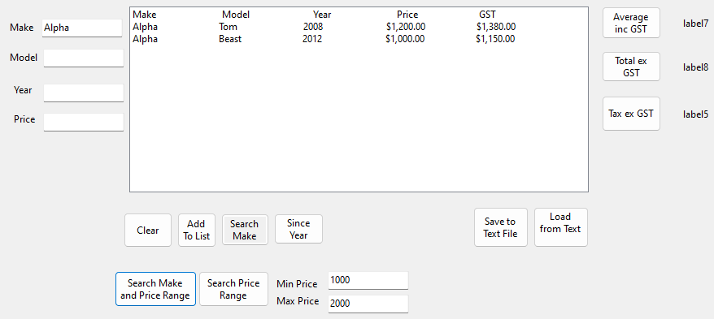
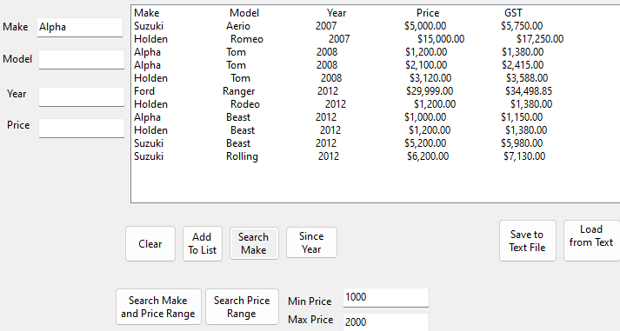

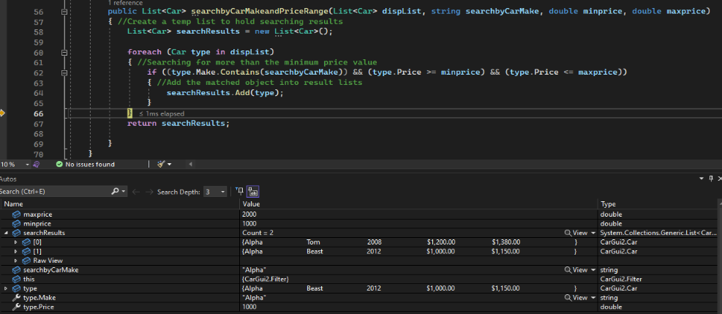
Debugging below confirms above second image count 2 cars which fit the search & “No search result” pops up if no data received
